Order No: 39 of 2025
Dated: 02-07-2025

Subject: Reassignment of Duties.
To ensure efficient administration and seamless operational continuity, the following officials of this institution are hereby reassigned duties, effective immediately:
S.No |  | Name of the Official | Place of Duty
1 |  | Saleem Farooq Najar | Workshop
2 |  | Saleem Farooq | Electrical Engg
3 |  | Umer Bilal | Mechanical Engg

Additional Instructions:
- Umer Bilal will report to the Mechanical Engineering Department in addition to his existing responsibilities.
- Saleem Farooq Najar will report to the Leather Technology Department for a period of 15 days from the date of issuance of this order. After this period, he will report to the Workshop for further duties.

This order is effective from the date of issuance.

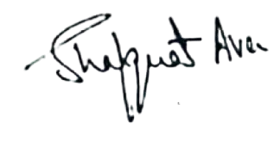

No: KGP/Estt/2025/516
Dated:02-07-2025
Dr. Shafquat Ara
Principal
Kashmir Govt.Polytechnic College Srinagar

Copy to:
- Concerned HOD’s/Incharges for information.
- Concerned officials for compliance.

